**PROJECT TITLE**

**College Name:** NANDHA ARTS AND SCIENCE COLLEGE (AUTONOMOUS)

**College Code :** bru4j

**TEAM ID:**

**TEAM MEMBERS:**

**Team LeaderName:V.kousik**

Email: kousikdon15@gmail.com

**Team Member1: M.Ashfaaq**

Email: ashfaaq.m0786@gmail.com

**Team Member2: R.Kamesh**

Email: masskamesh123456@gmail.com

**Team Member3: N.Kasinathan**

Email : kk3266056@gmail.com

**1.INTRODUCTION**

**Project Overview:**

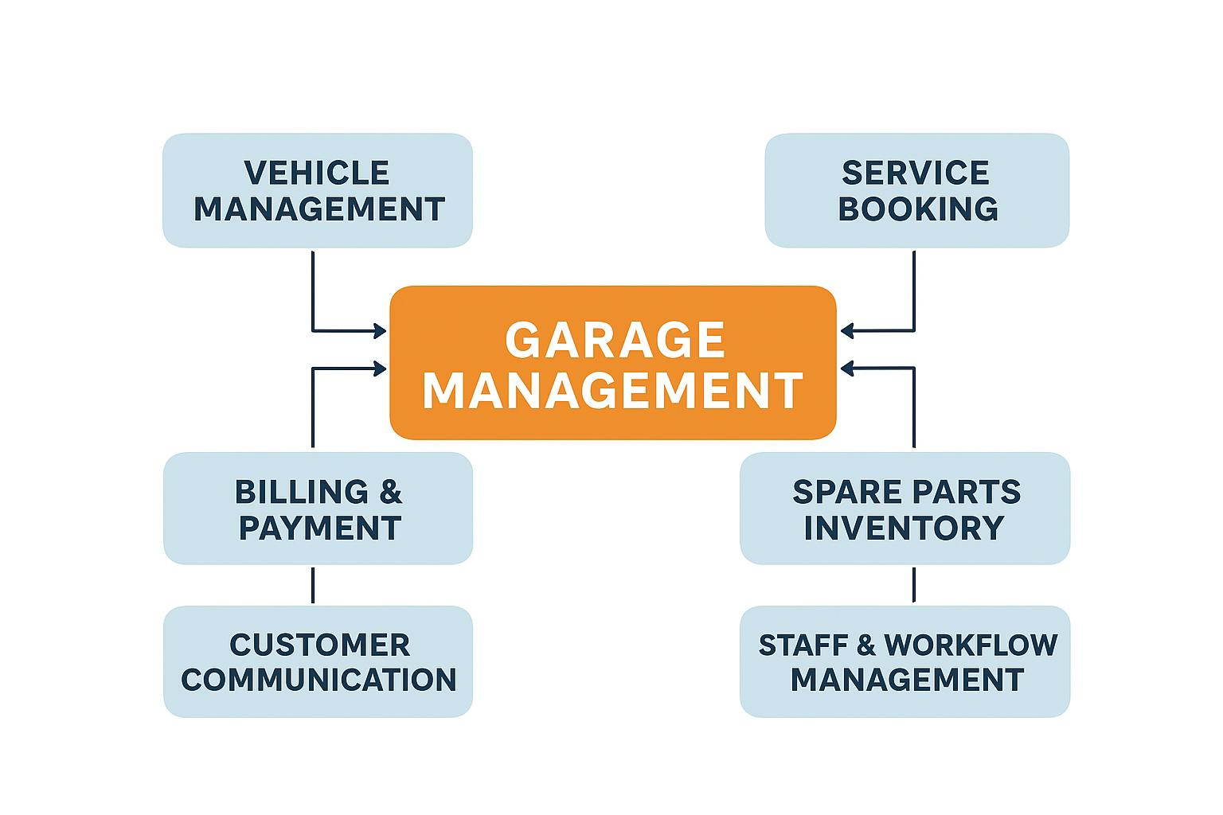 The Garage Management System is a Salesforce-based application that automates vehicle service center operations, including customer details, service bookings, repairs, billing, and inventory. By using Salesforce features like Flows and Approval Processes, it improves efficiency, reduces errors, and enhances customer satisfaction.

**Purpose :**

The project aims to provide a centralized system for garage operations, reducing manual work, ensuring accurate service tracking, improving customer communication, and enhancing efficiency, inventory management, and record-keeping to build customer trust and support business growth.

**DEVELOPMENT PHASE**

**Creating DeveloperAccount:**

**By using this URL-** <https://www.salesforce.com/form/developer-signup/?d=pb>

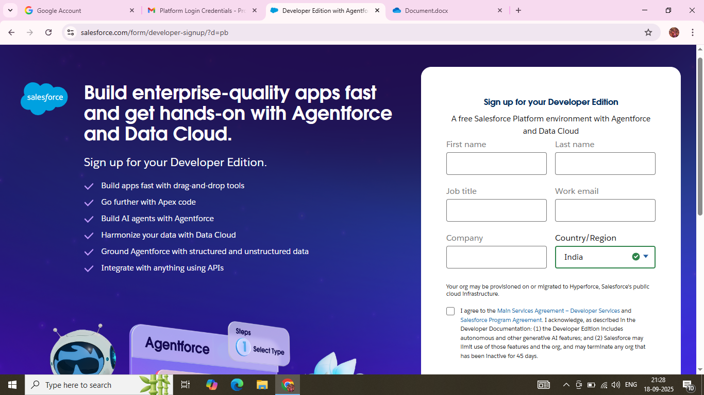

**Created Objects: Customer Detail, Appointment, Service Records, Billing Details and Feedback**

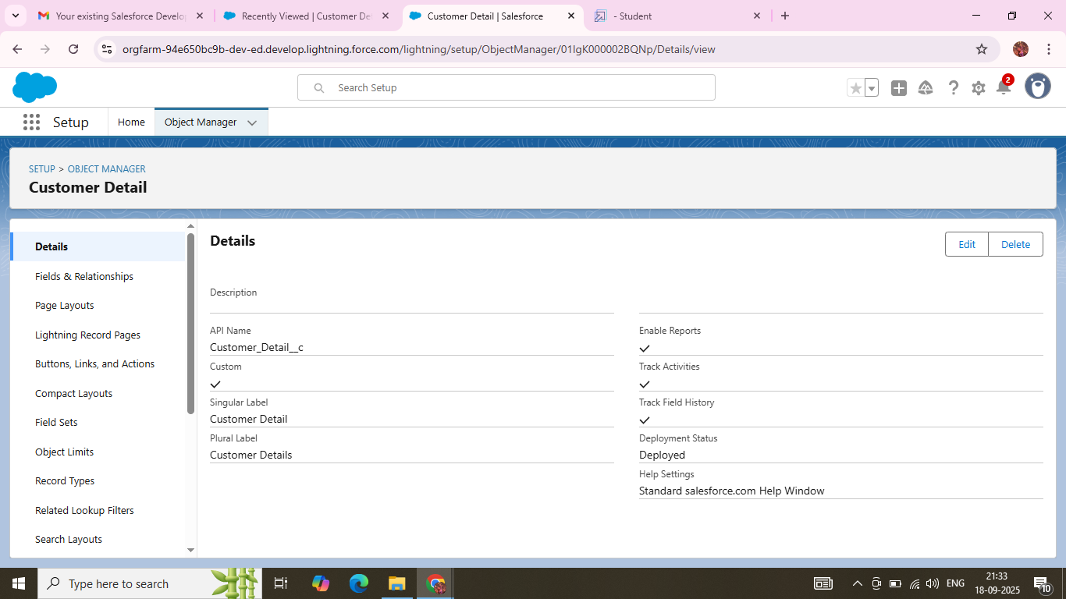

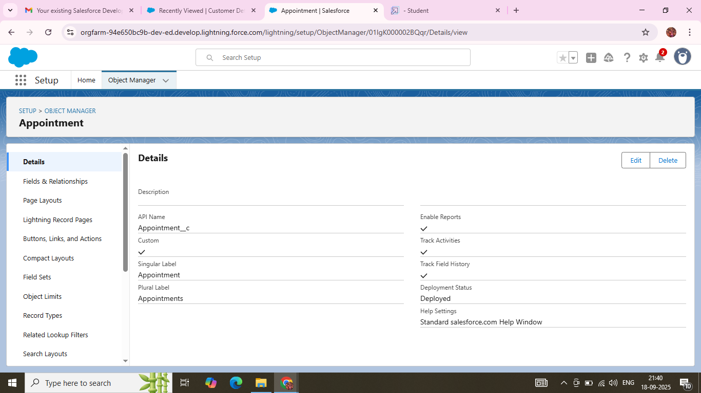

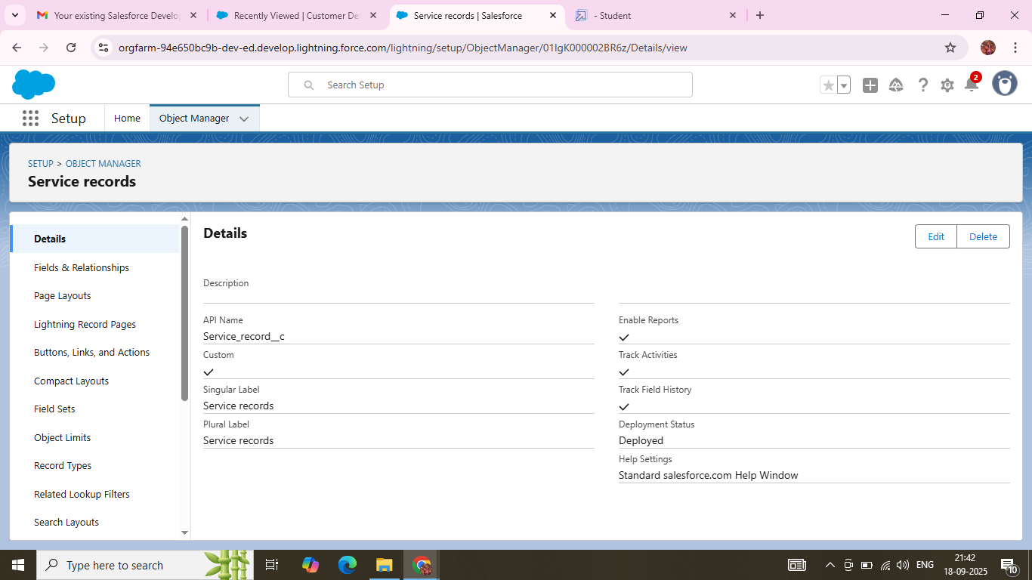

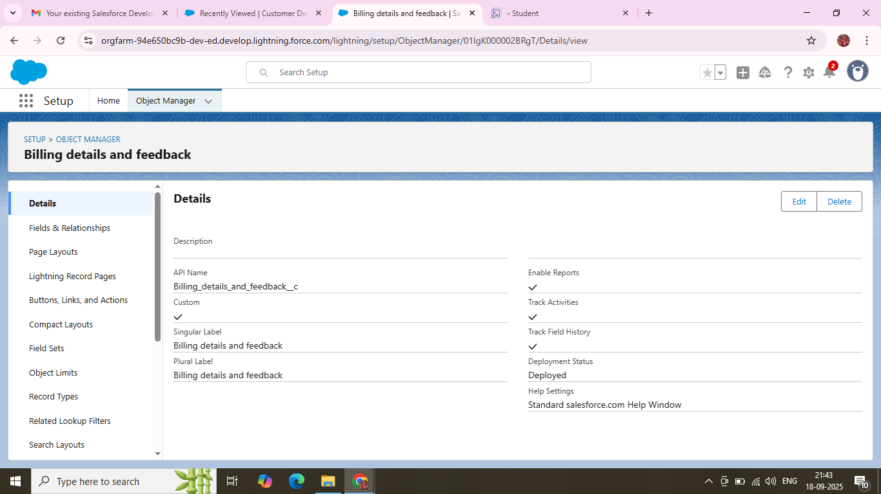

**Created Tabs:** **Customer Details, Appointment, Service Records, Billing Details and Feedback**

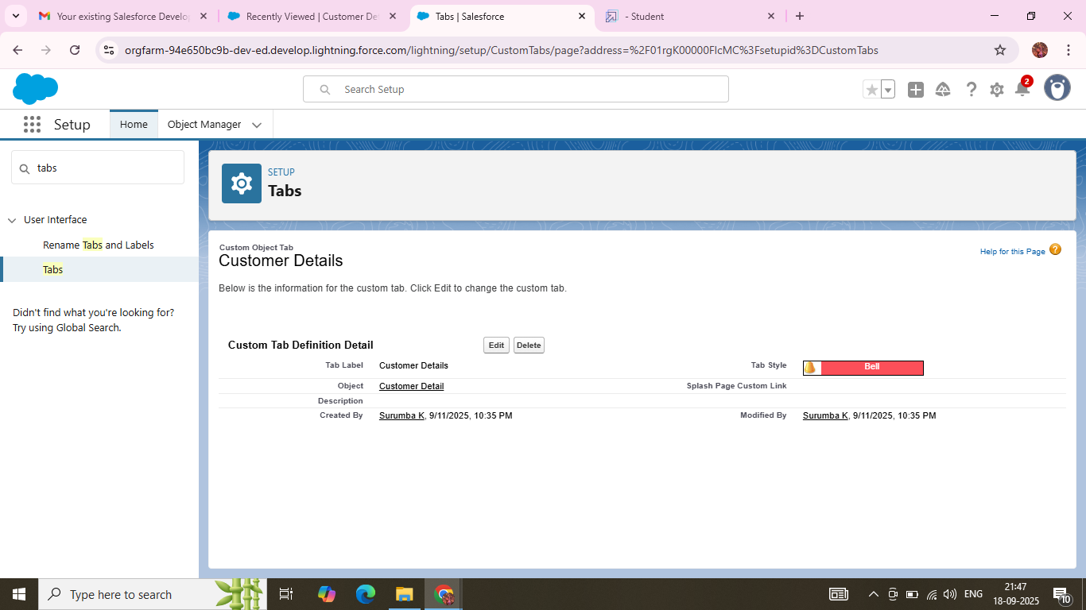

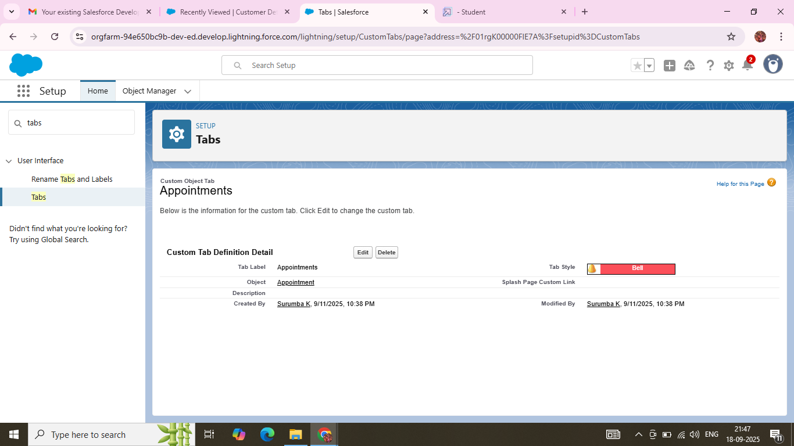

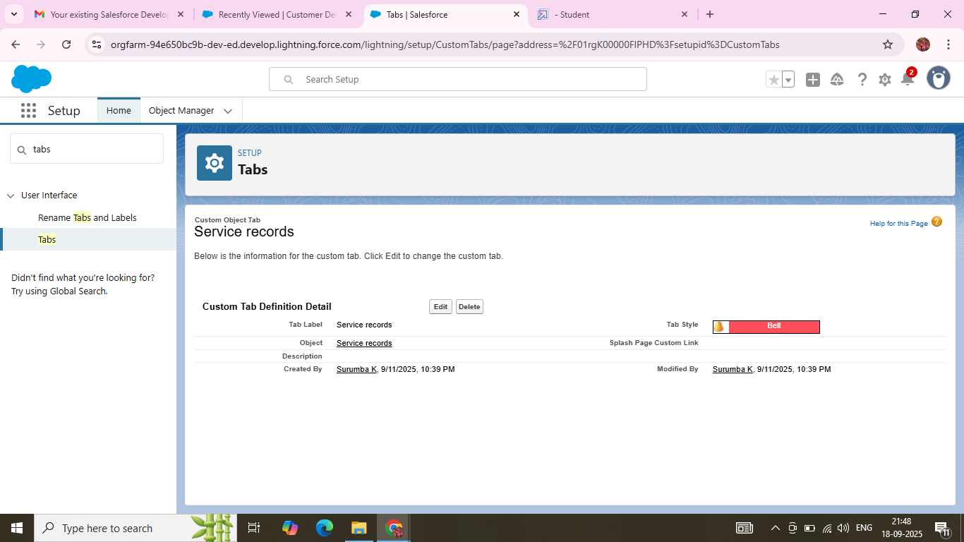

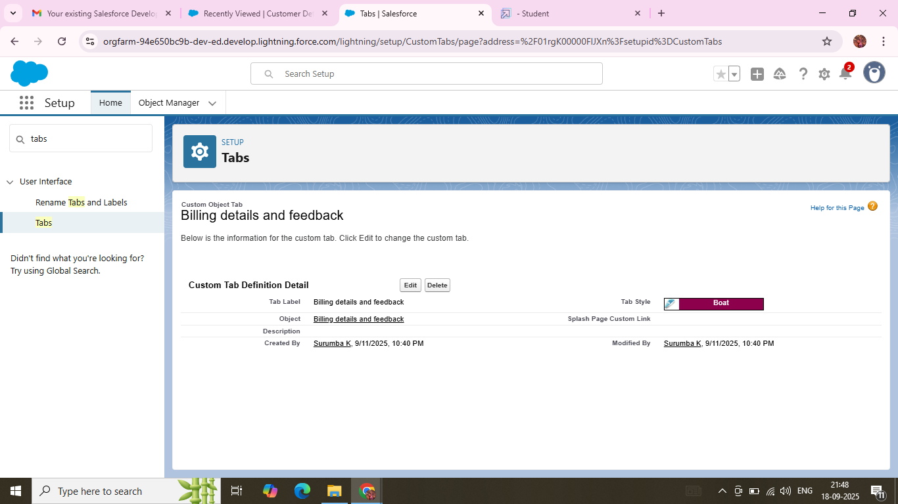

**Created Lightning App:** **Garage Management Application**

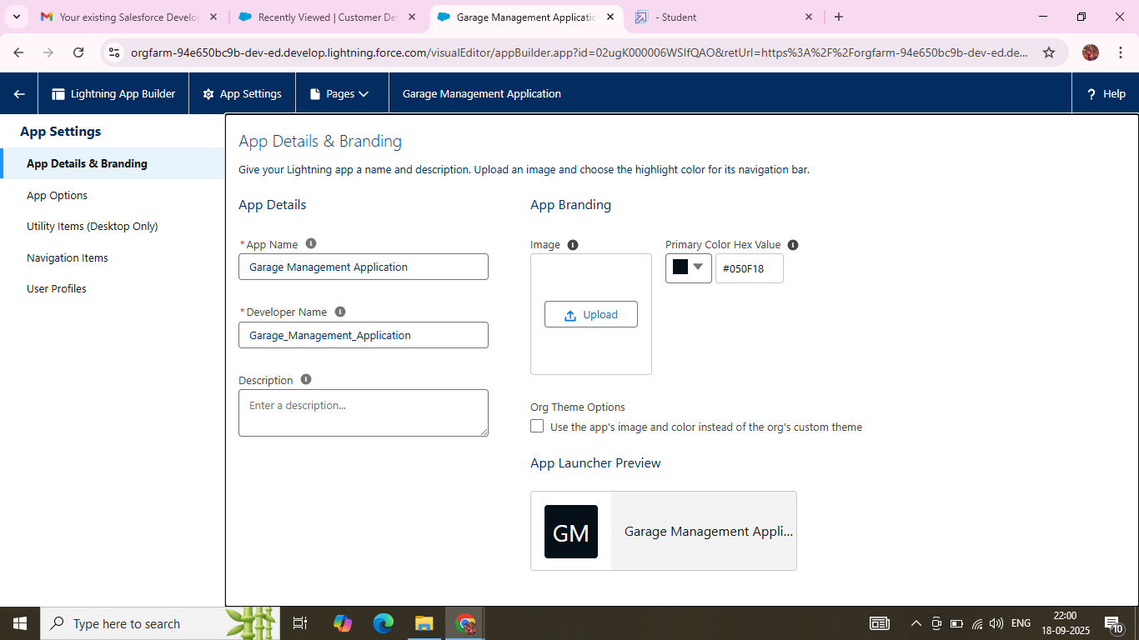

**Created fields in an object for: Customer Details (Phone Number) (Gmail)**

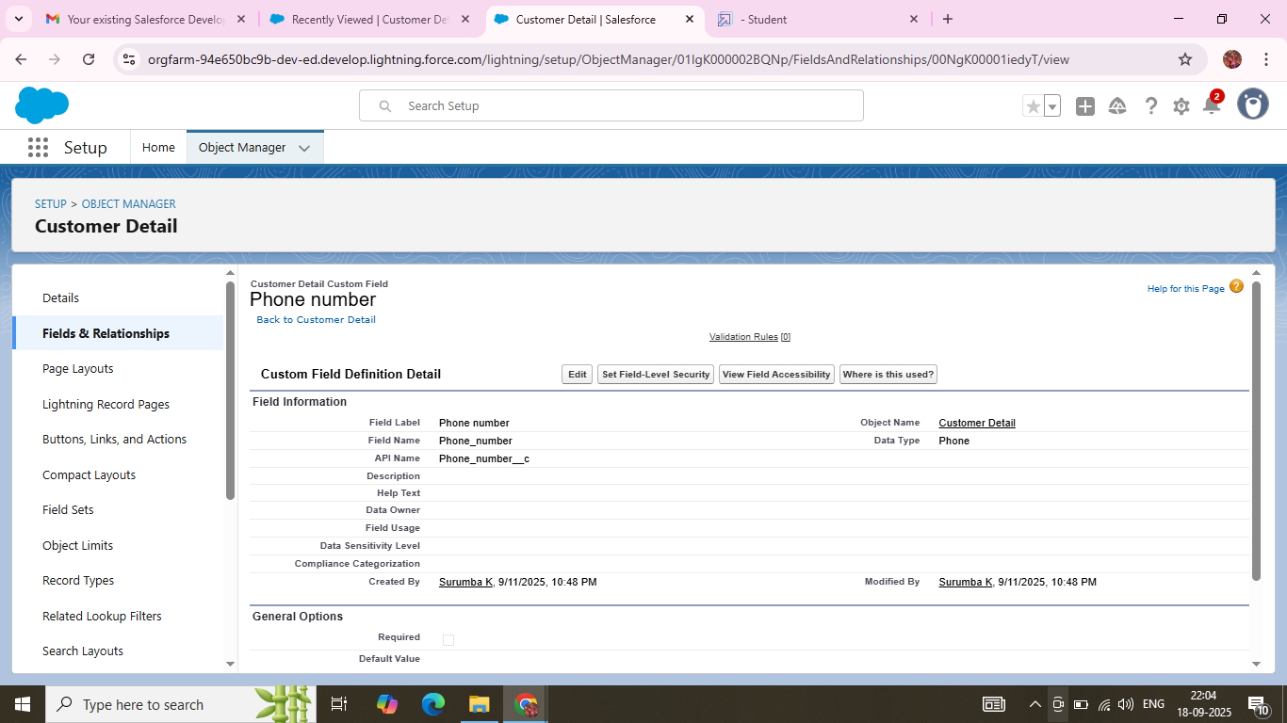

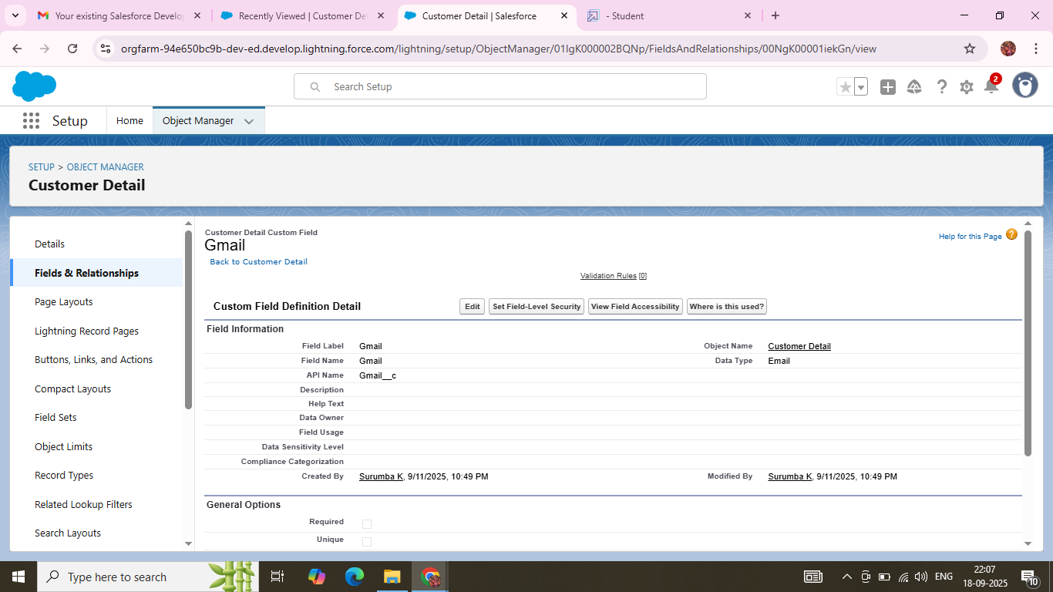

**Creation of Lookup Field on Appointment Object :(Customer Detail)**

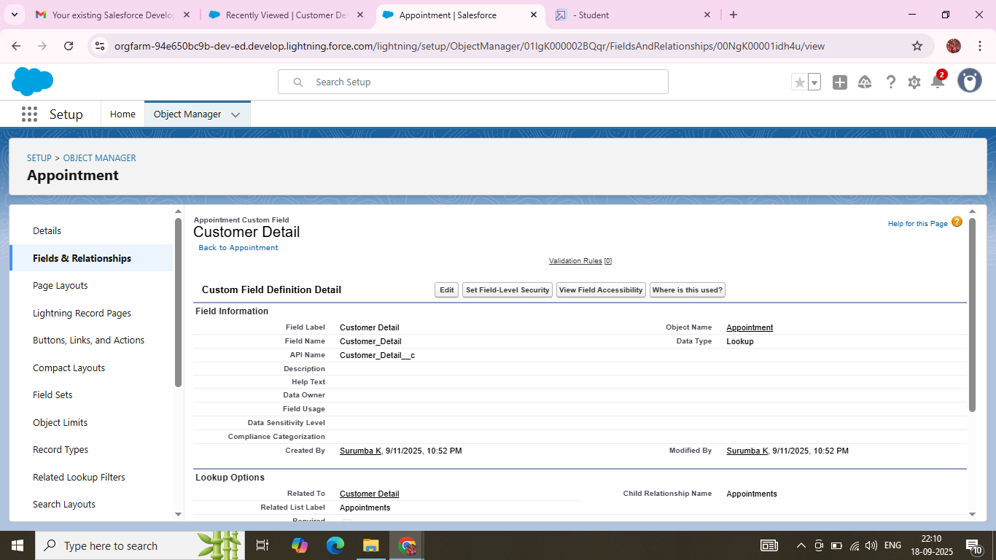

**Creation of Lookup Field on Service Records Object : (Appointment)**

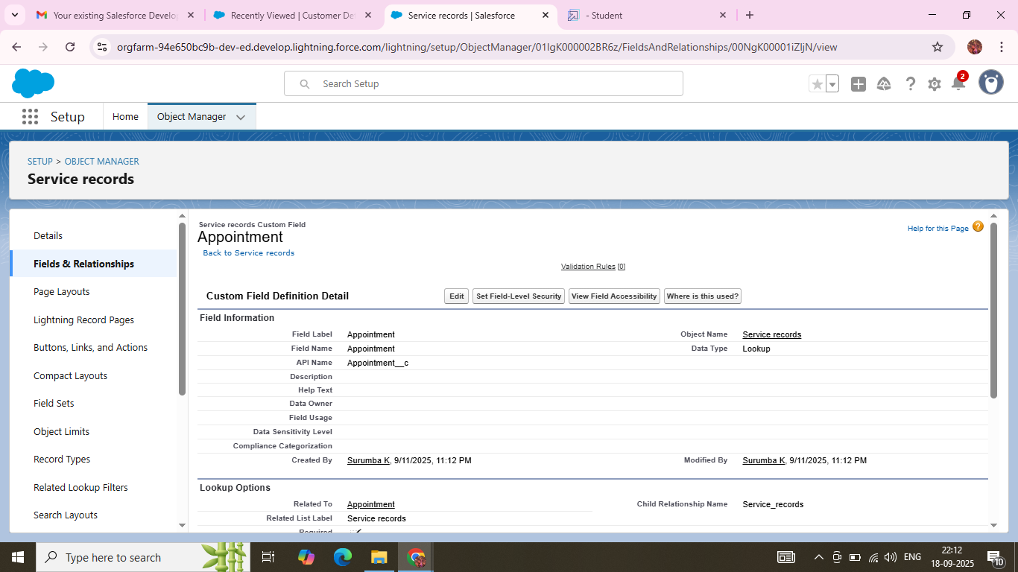

**Creation of Lookup Field on Billing details and feedback Object :(Service Records)**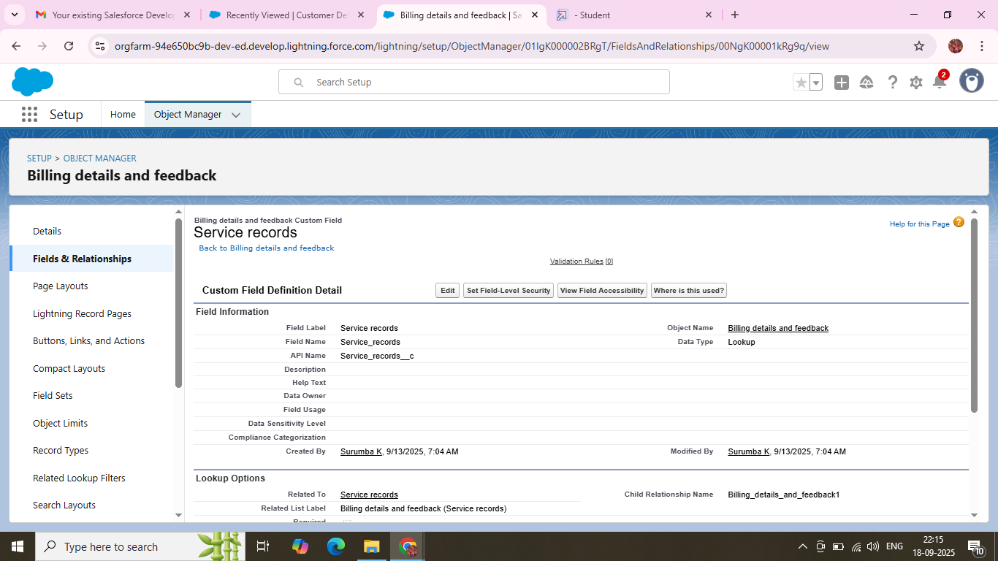

**Creation of Checkbox Field on Appointment Object :(Maintenance service,Repairs,** **Replacement Parts)**

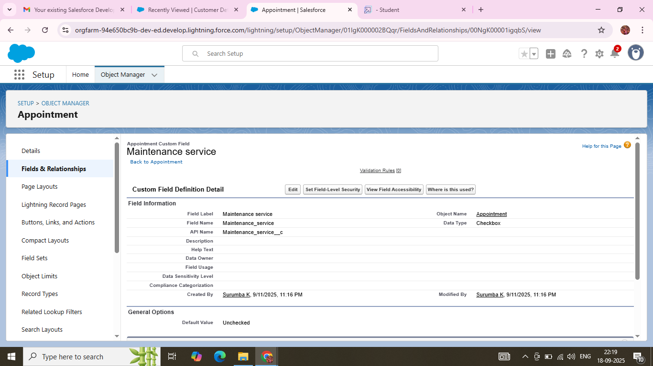

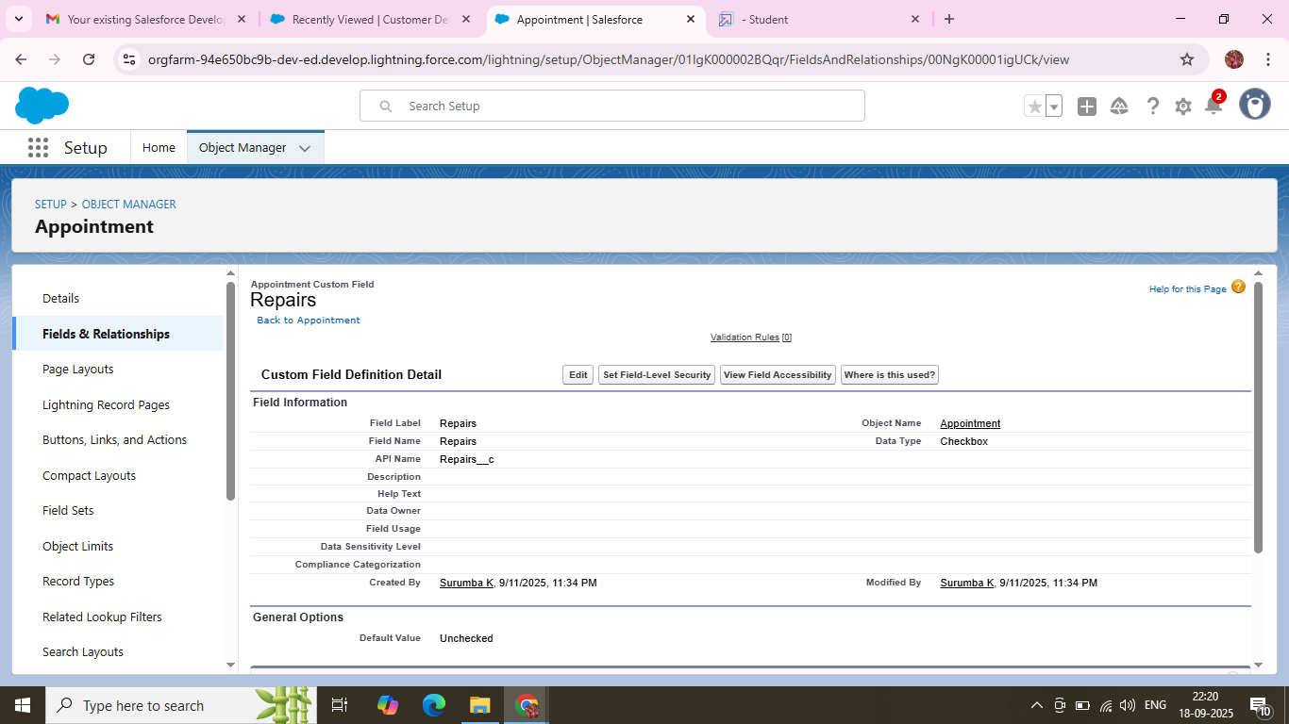

**Creation of Checkbox Field on Service records Object :(Quality Check Status)**

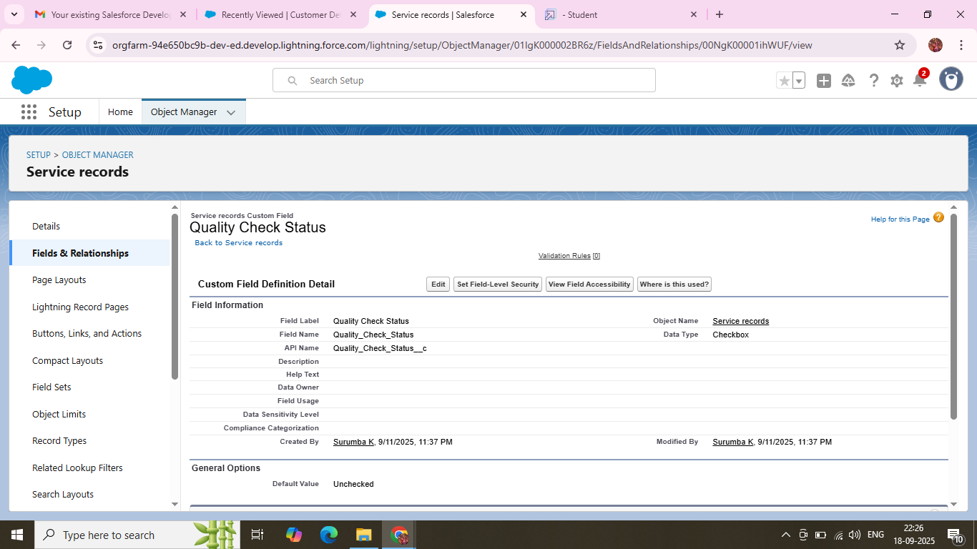

**Creation of Date Field on Appointment Object :(Appointment Date)**

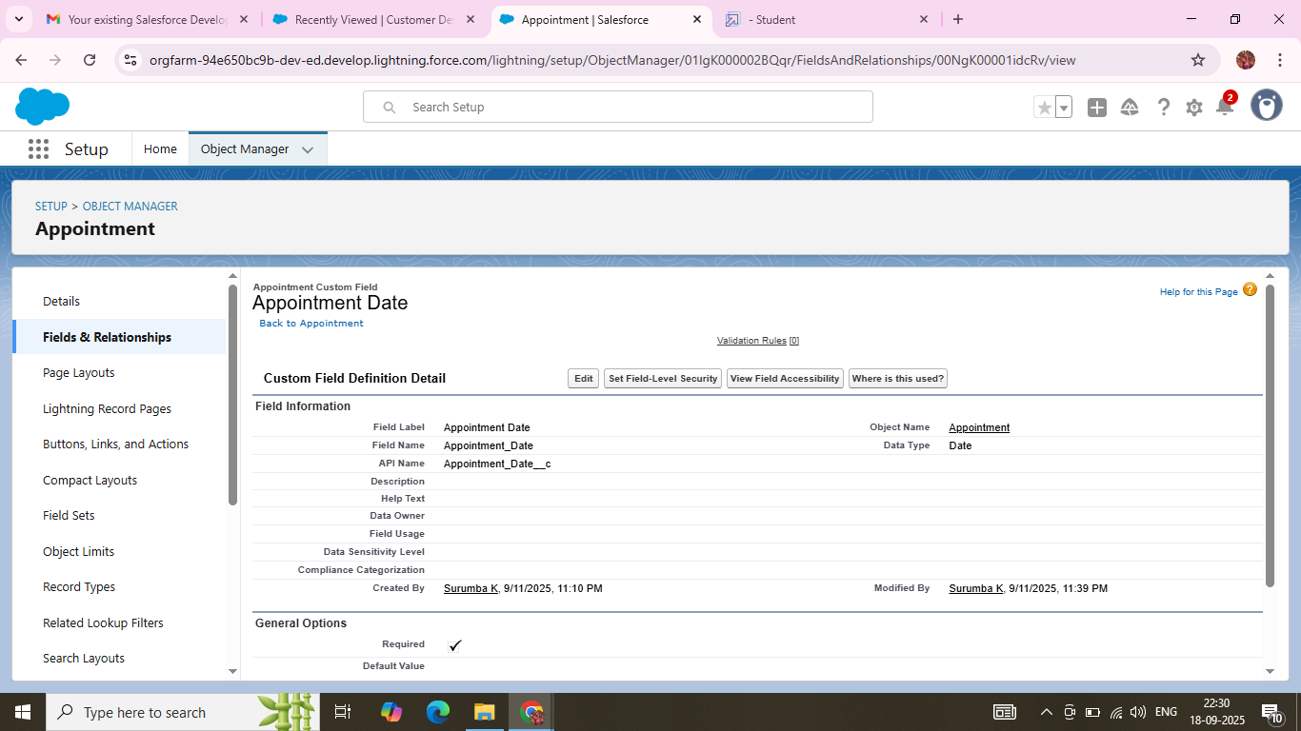

**Creation of Currency Field on Appointment Object :(Service Amount)**

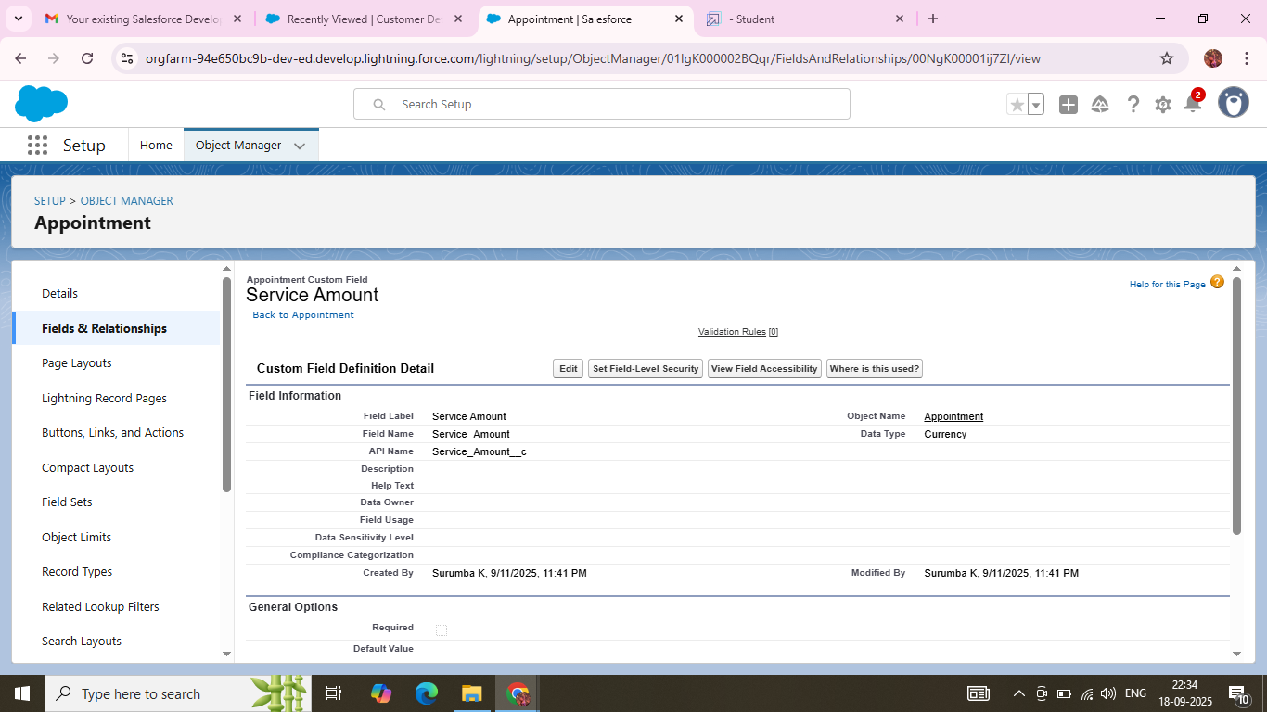

**Creation of Currency Field on Billing details and feedback Object :(Payment Paid)**

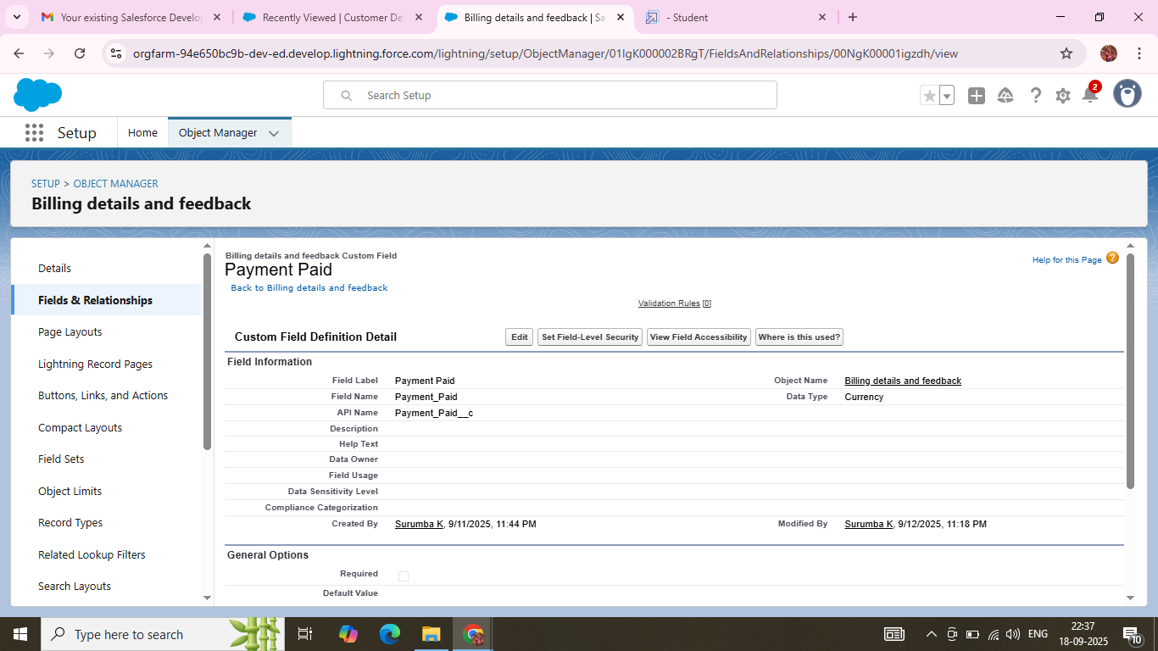

**Creation of Text fields on Appointment :(Vehicle number plate)**

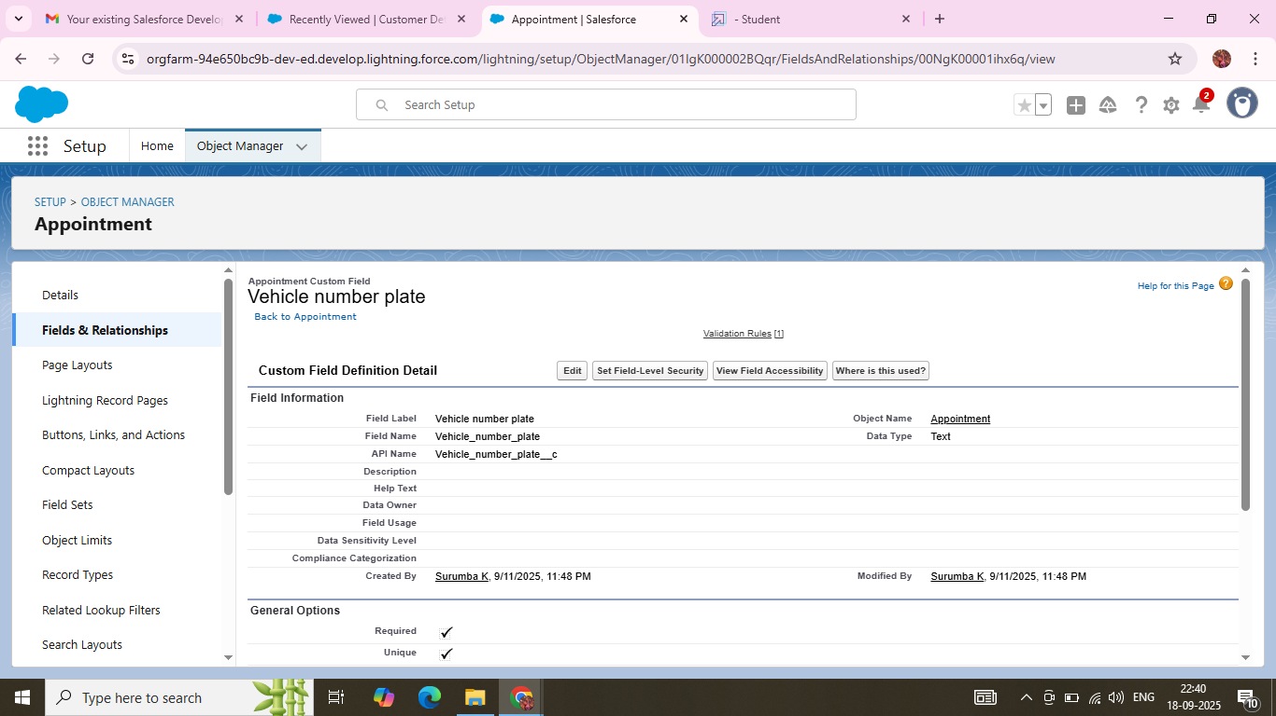

**Creation of Text Fields in Billing details and feedback object :(Rating for service)**

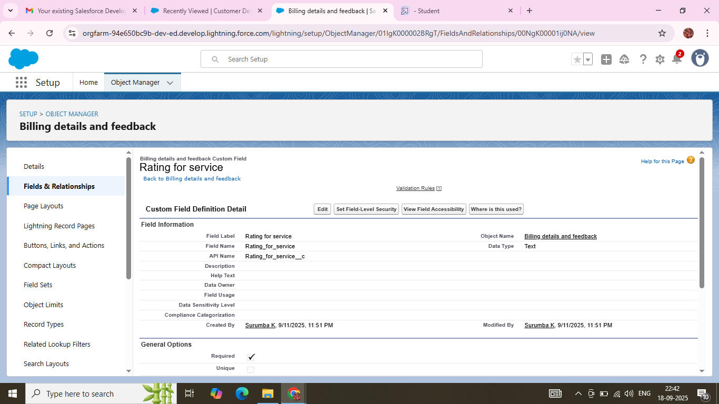

**Creation of Picklist Fields in Service records object :(Service Status)**

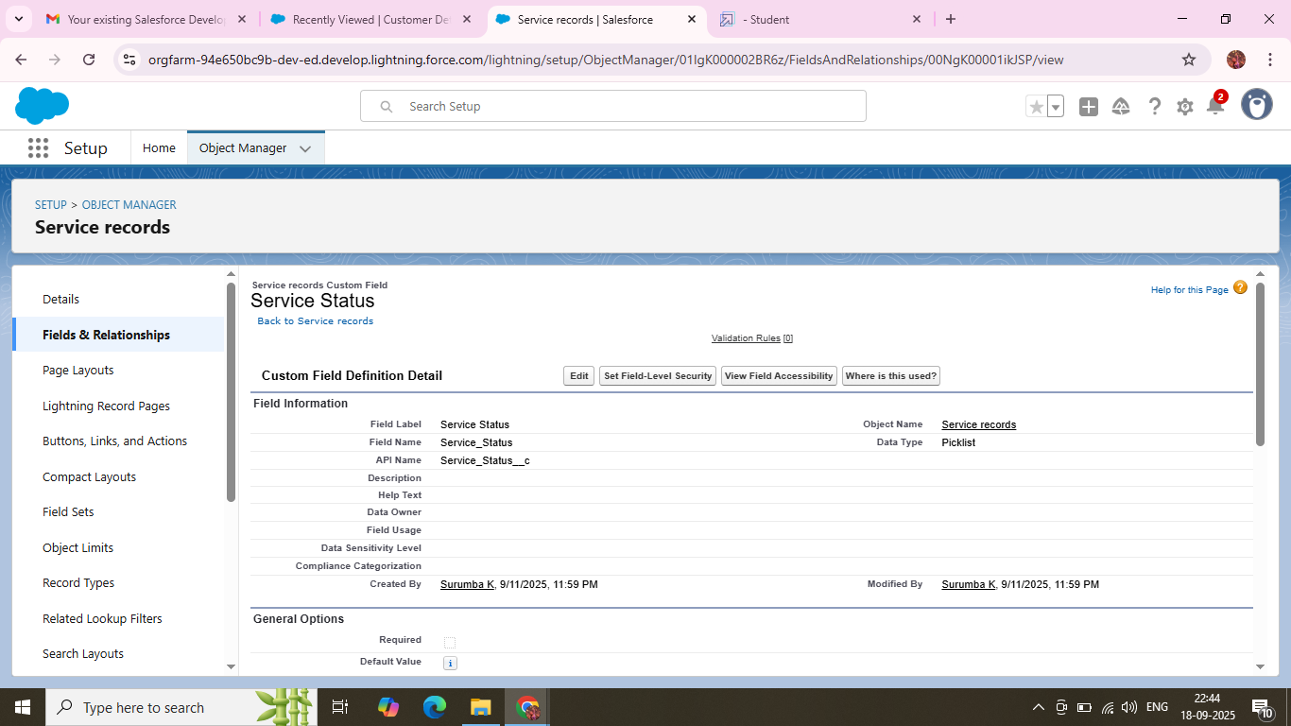

**Creation of Picklist Fields in Billing details and feedback object :(Payment Status)**

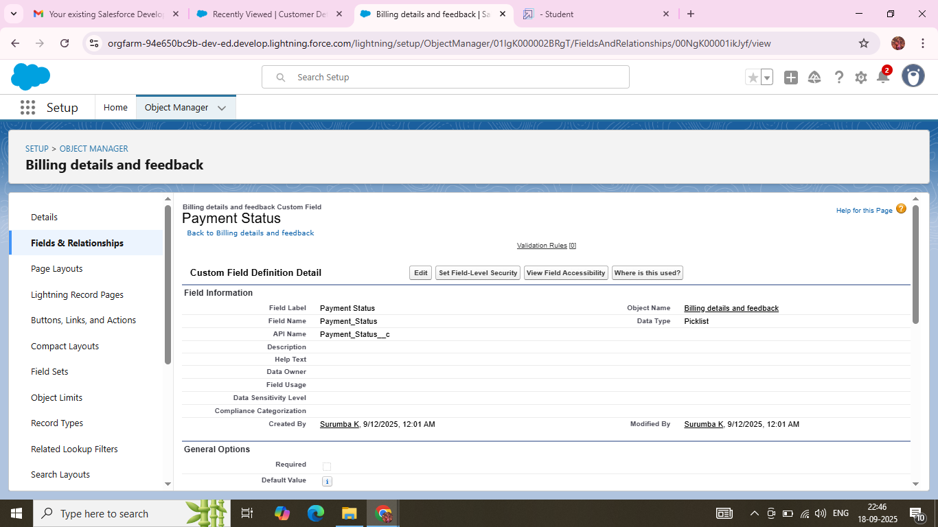

**Creation of Formula fields in Service records:(service date)**

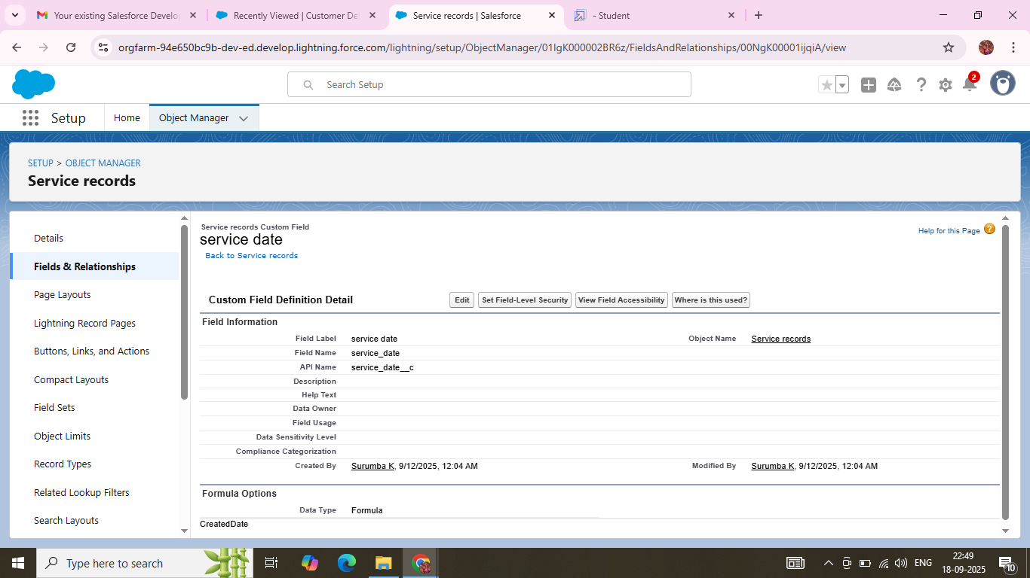

### **Validation Rules:**

### **To create a validation rule to an Appointment Object for an :** **Vehicle**

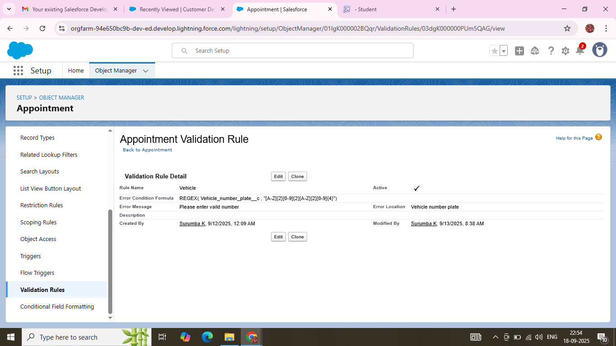

### **To create a validation rule to an Billing details and feedback object :**

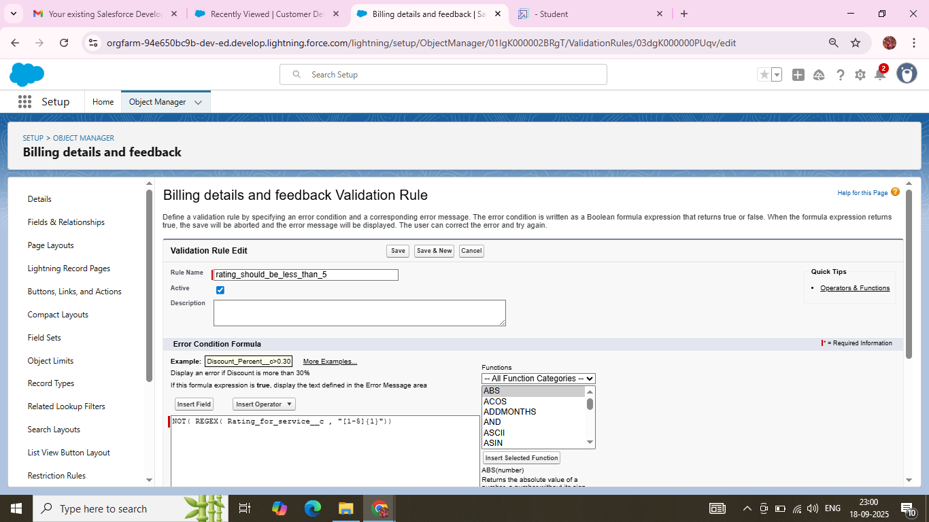

**Duplicate Rules:**

### **To create a matching rule to an Customer details Object:**

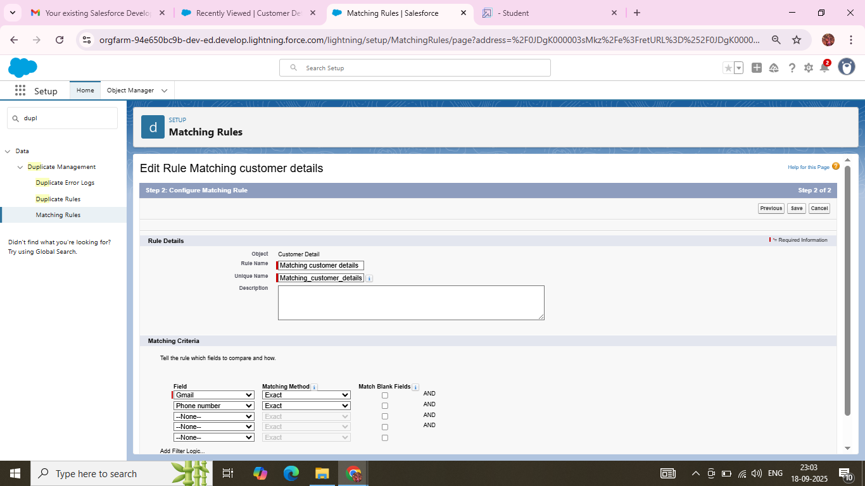

### **To create a Duplicate Rule to an Customer details Object:**

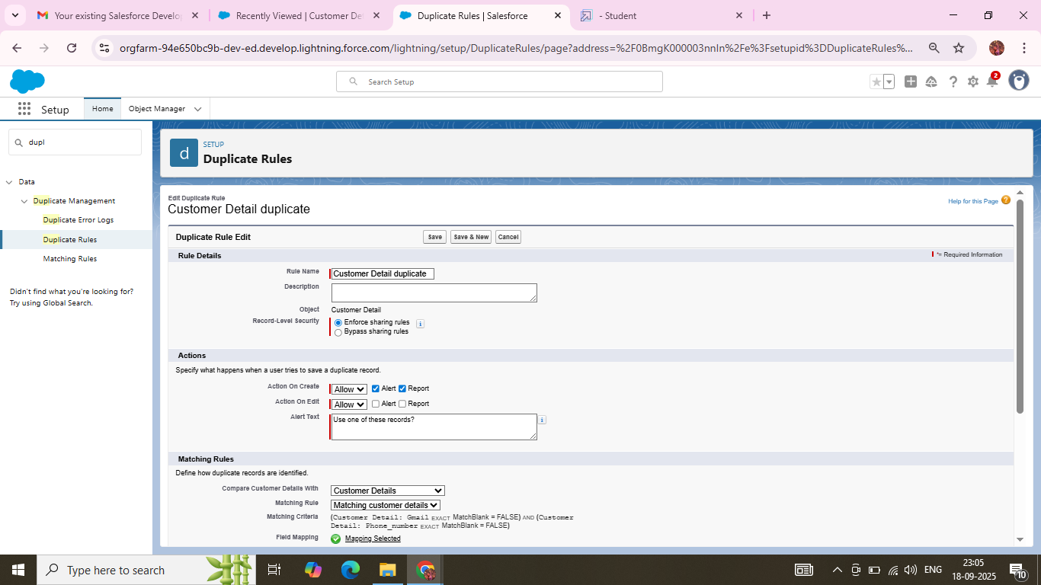

**Profiles:**

**To create a new profile As Manager :**

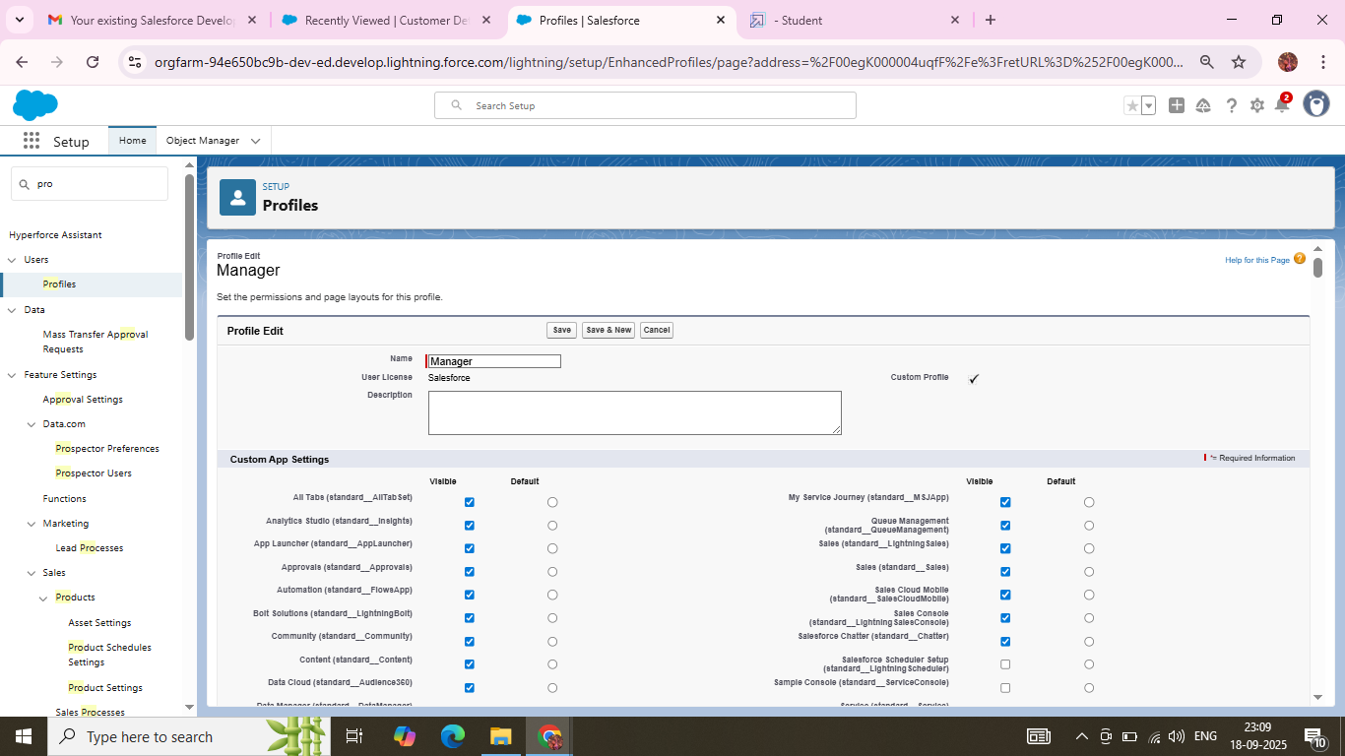

**To create a new profile As Sales Person :**

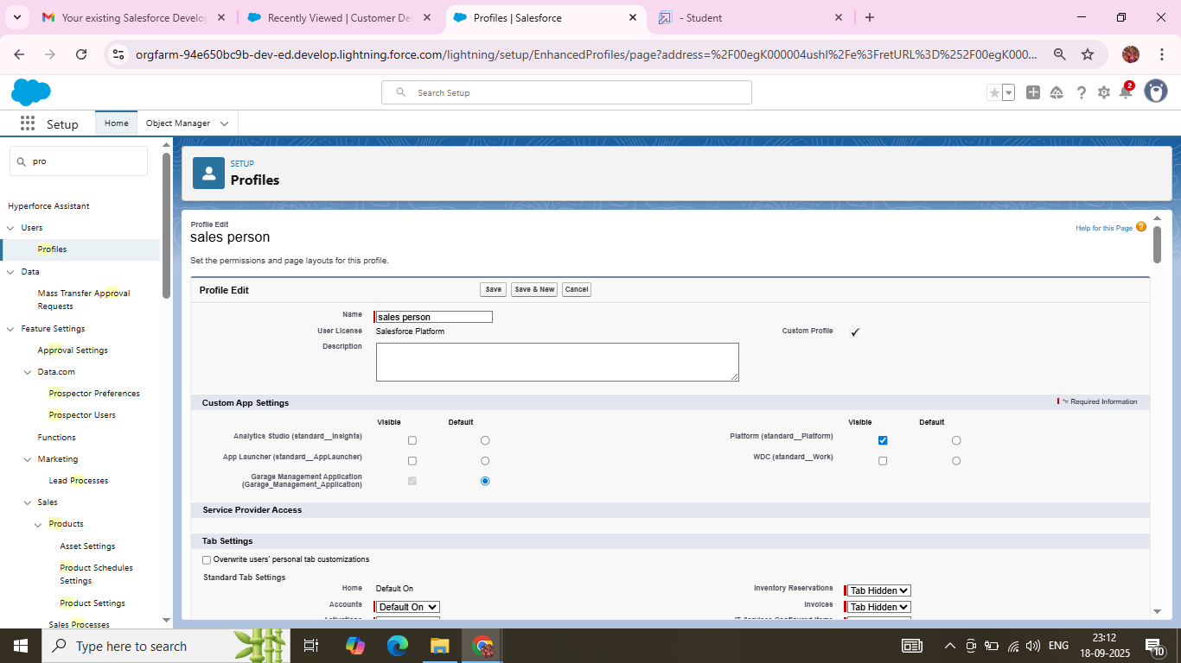

### **Role & Role Hierarchy :**

**Created a Manager Role and Sales Person under CEO:**

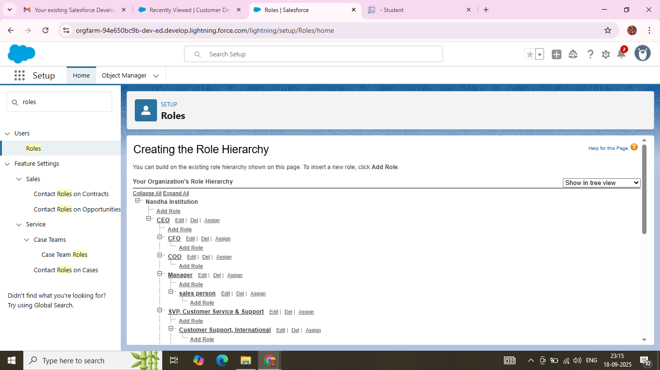

**Users:**

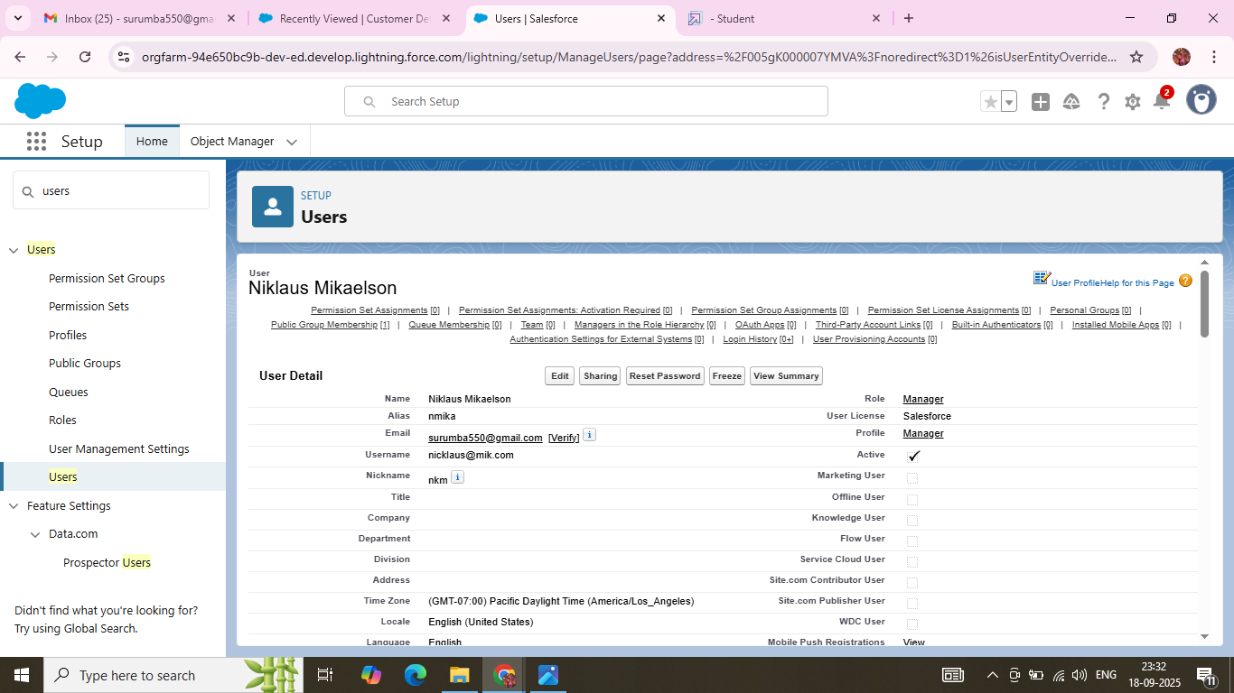

**Created an Another user Role as Sales Person:**

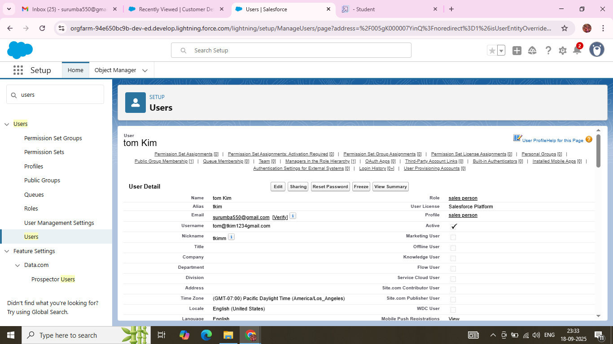

**Public Groups:**

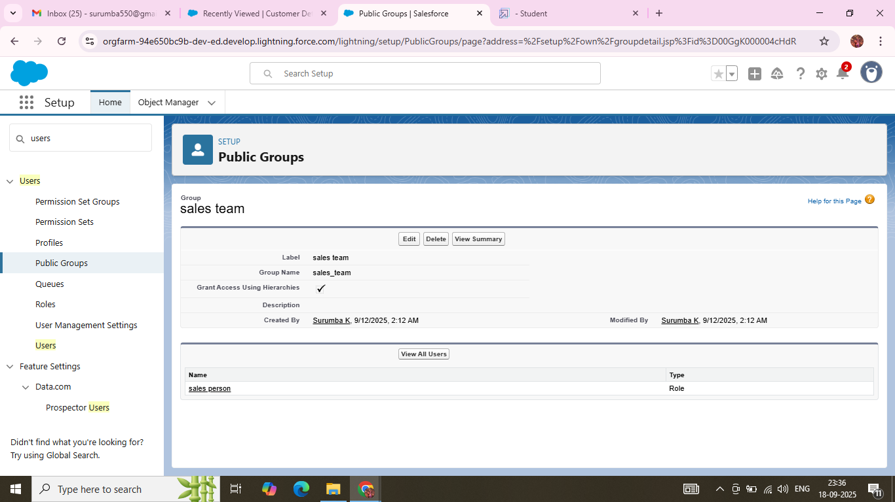

### **Sharing Setting:**

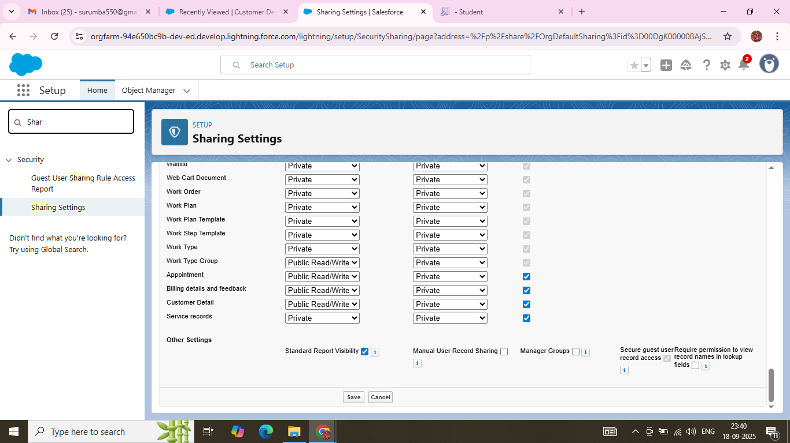

### **Flows:**

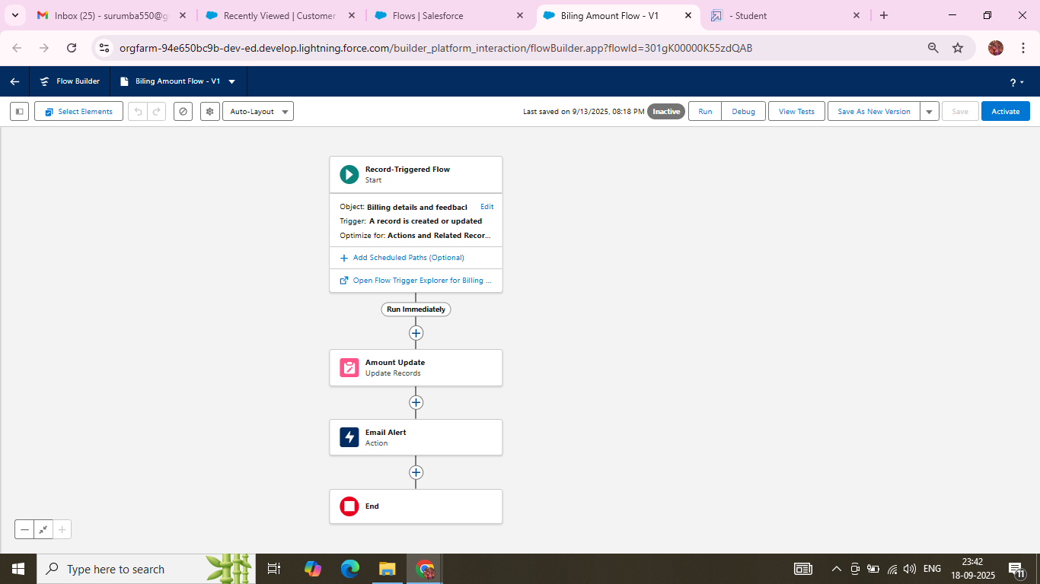

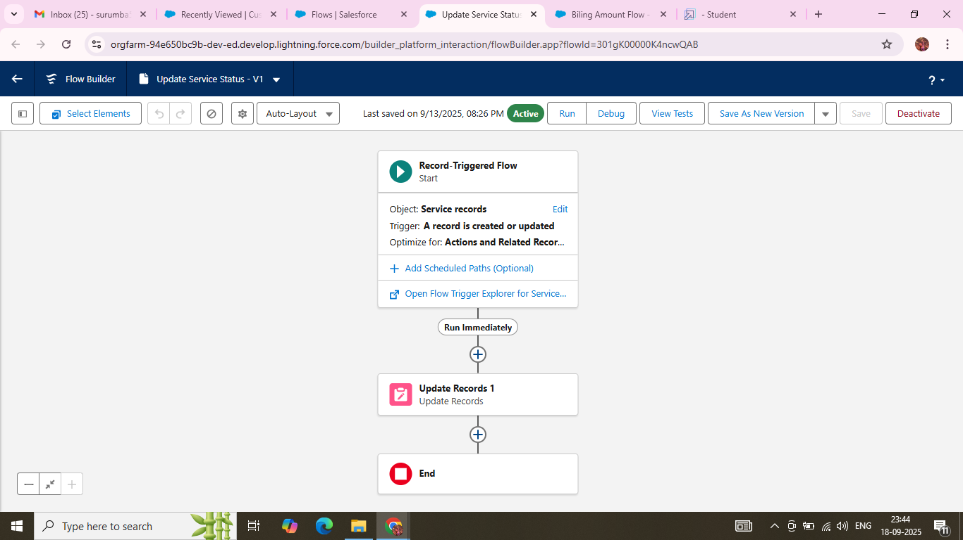

### **Apex handler:**

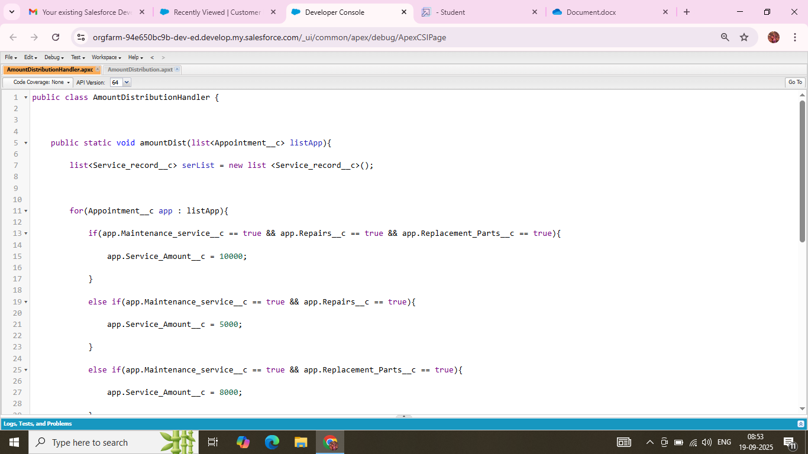

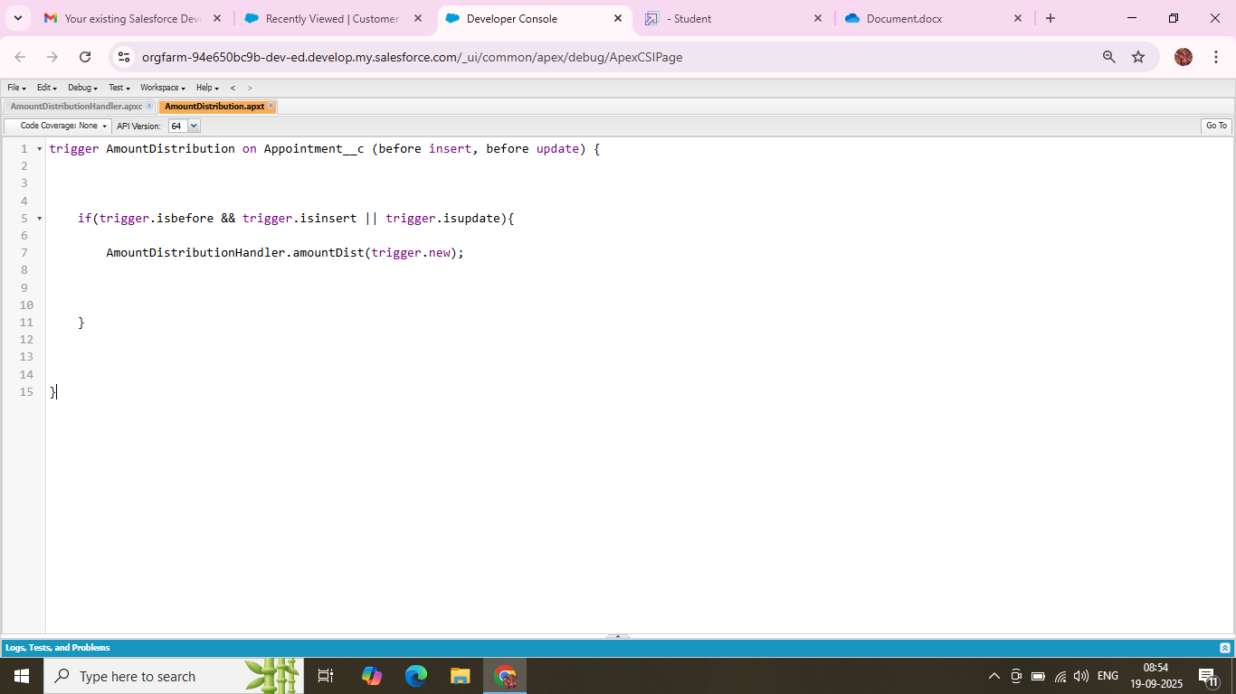

### **Reports:**

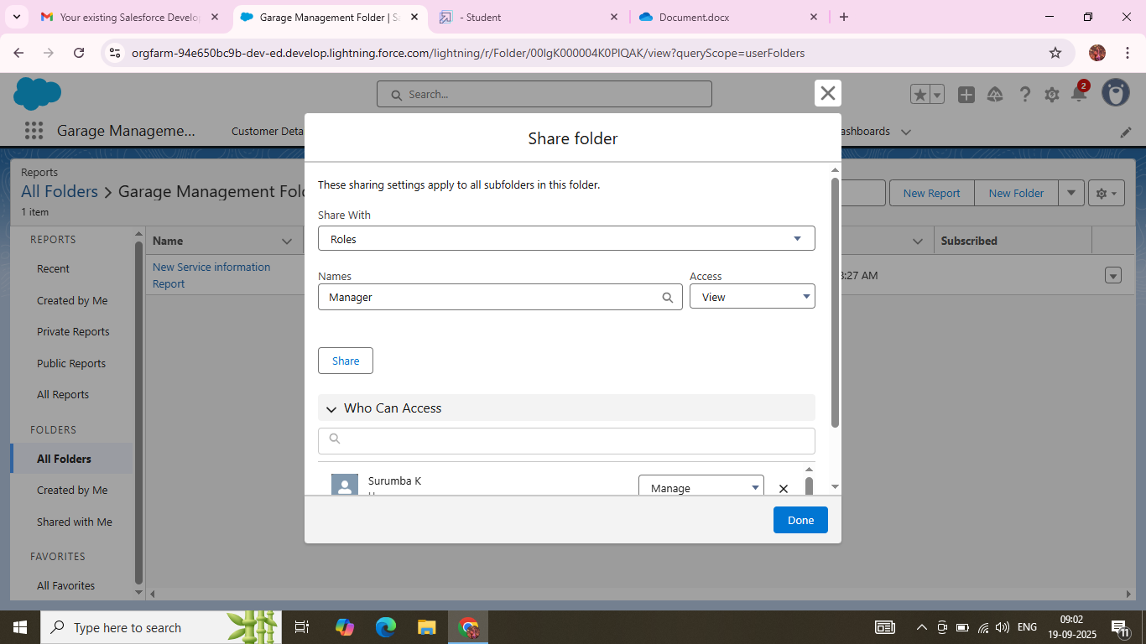

### **Sharing a report folder:**

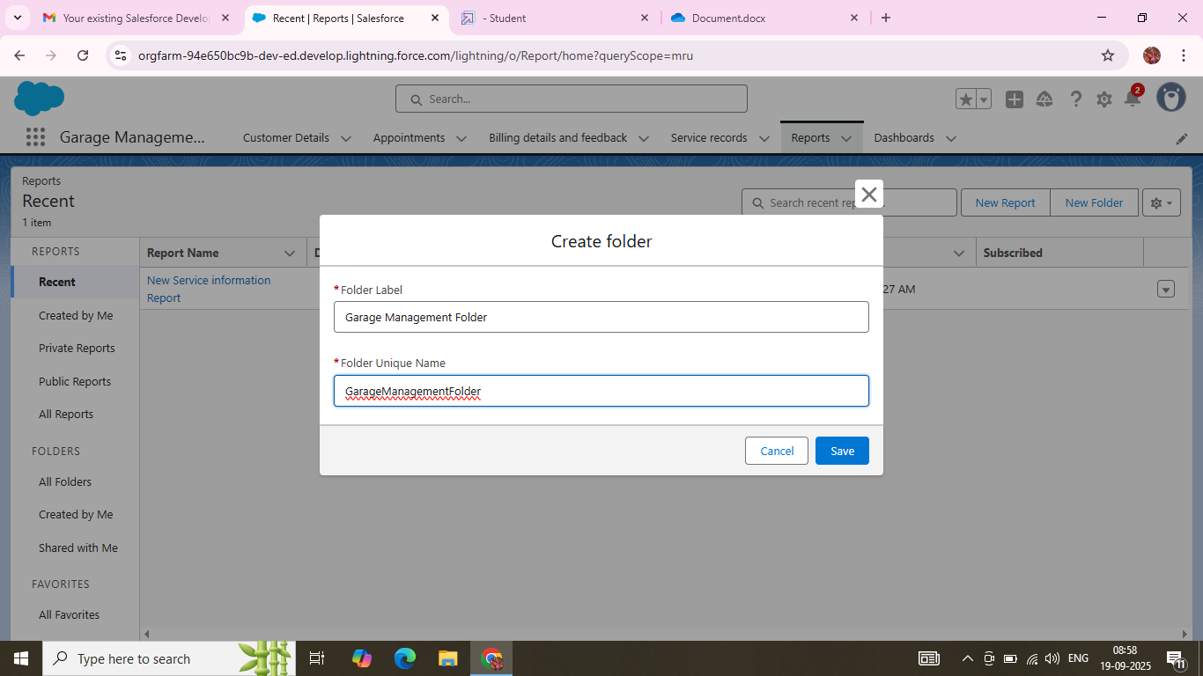

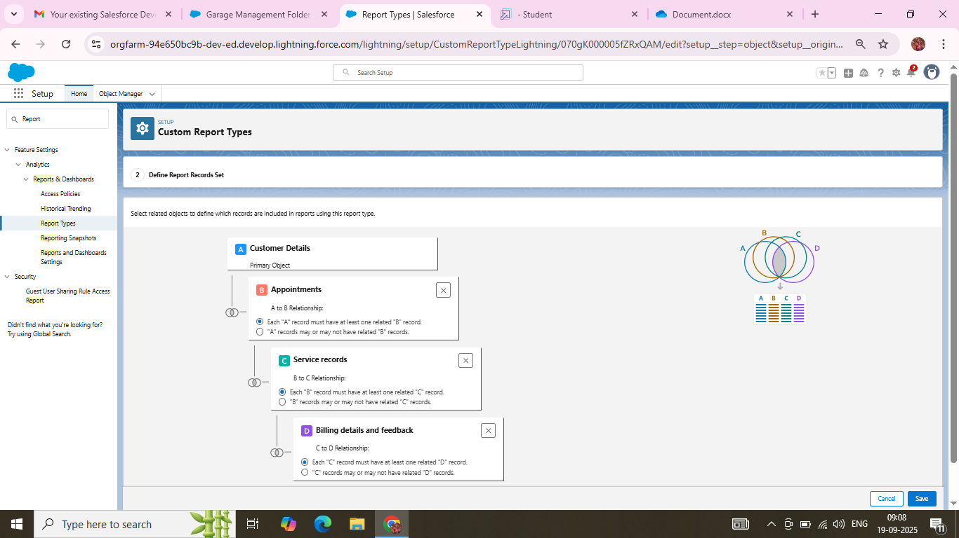

**Created Reports in Chart wise:**

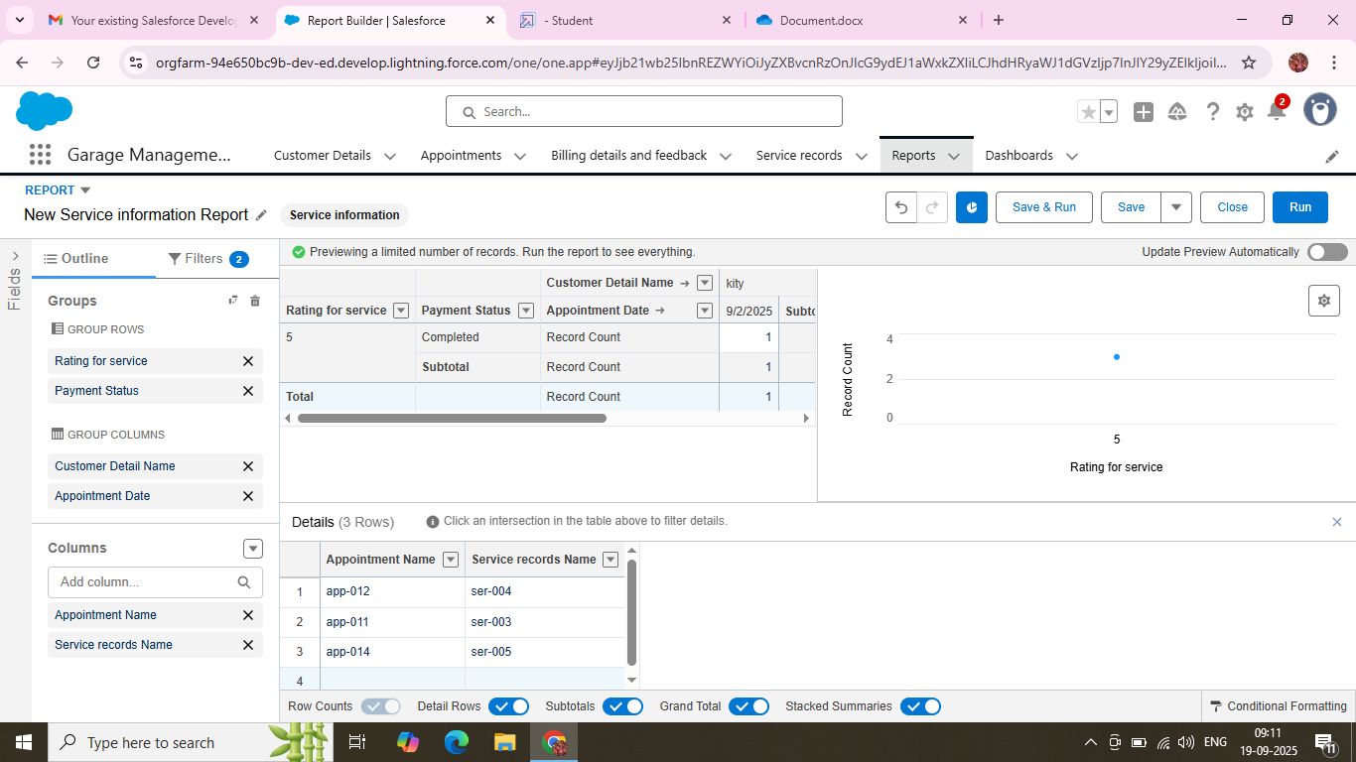

### **Created Dashboard Folder:**

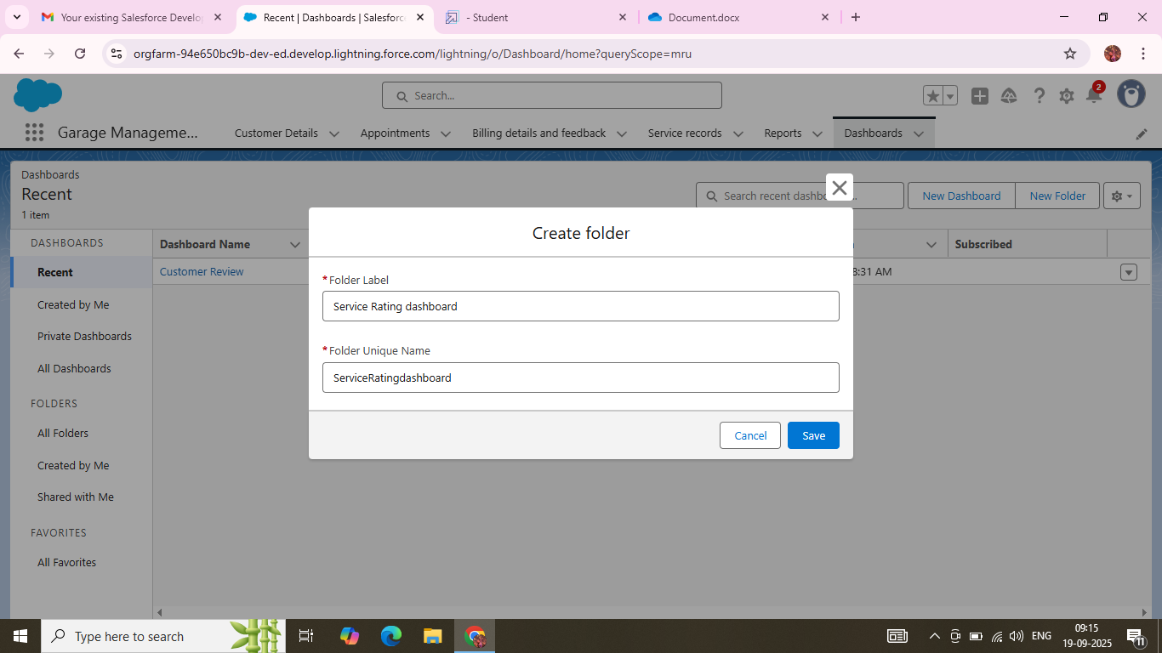

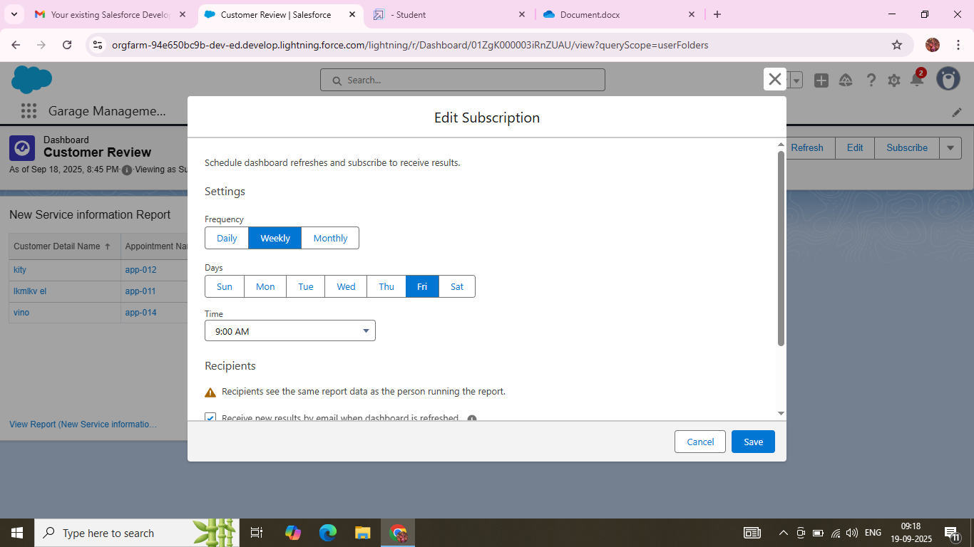

### **User Adoption :**

